INVICTUS Racing Wheelchair BikeBox
Trial Assembly
We recommend that you have a practice of putting the two halves together as there is a little technique to learn in closing the bikebox. The warmer the box the easier it is.
It is normal for the sides to be bowed on unpacking. The specially formulated plastic is designed to be highly flexible; this gives it the super energy absorbing characteristics that are necessary to protect the Racing Wheelchair from the potential knocks and bangs that the bikebox will receive at the airports.
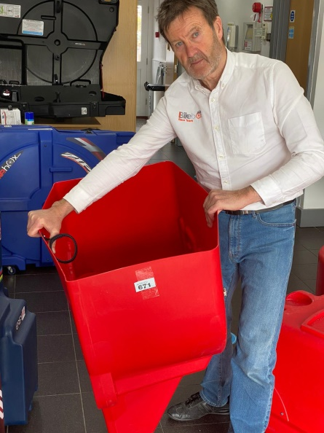
- Packing the INVICTUS into the cardboard box will have caused a little extra distortion. So you will need to force the sides out once as in illustration (a). Don’t be scared to give it a good pull, you cannot damage the plastic, this will not remove all the distortion but that will not matter.

- Slide the two halves together, this is easier if the box is at room temperature and you have the INVICTUS in a vertical position

- A little manoeuvring is necessary; it is easier if you line up the 2 clasps in the centre of each side before you line up the outer clasps. Once they are all lined up commence closing all remaining 4 clasps.

Maintenance
The INVICTUS box requires very little maintenance.
- Bike boxes are often exposed to hostile, often wet environments. Twice a year wipe a little light oil onto the clasps and some on the caster wheel bearings.

- If the tongues on the clasps become bent because of abuse by the baggage handlers, simply bend them back with a pair of pliers / grips.

- If you can, store the Invictus in a fully closed position with clasps closed, this keeps the bike box taught and in shape. Or if you are struggling for space the two halves can slip inside one another as it original arrived in the cardboard box.

- The Bike Box should always be stored in a dry place.
View our video to see how to pack your Racing Wheelchair into the INVICTUS bikebox https://youtu.be/lNYKPI6aj7E

www.bikeboxalan.com +44 (0)1709 365408 bikeboxalan@gmail.com

